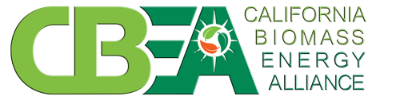

California Biomass Energy Alliance Commends Governor Brown for Assisting the Biomass Industry by Signing Senate Bill 859

FOR IMMEDIATE RELEASE Contact: Matt Ross
Wednesday, September 14, 2016 (916) 206-9818

SACRAMENTO – Executive Director of the California Biomass Energy Alliance (CBEA), Julee Malinowski-Ball, issued the following statement after Governor Jerry Brown signed Senate Bill 859.

“We commend Governor Jerry Brown for signing Senate Bill 859. The Governor understands the importance of the biomass industry as it pertains to the state’s renewable energy portfolio standard and the eradication of dead and dying trees from high hazard fire zones.

“This law will provide some certainty to the biomass industry which has struggled due to antiquated contracts. Under SB 859, investor-owned utilities and large public-owned utilities must enter into five-year contracts for a portion of at least 125 megawatts of power from biomass facilities that generate electricity through the use of forest materials removed from specific high fire hazard zones.

“Most importantly, this law protects hundreds of jobs, reduces greenhouse gas emissions and promotes long-term forest management goals.

“CBEA praises the Governor and the Legislature for their ongoing support of the biomass industry.”

# # #

